Pdf used for comparison

Rebel-large Hugging face Model
Seq2seq model
Uses the BART model to convert raw sentences into relation triplets.
Creates fixed number of triplets almost all the time.
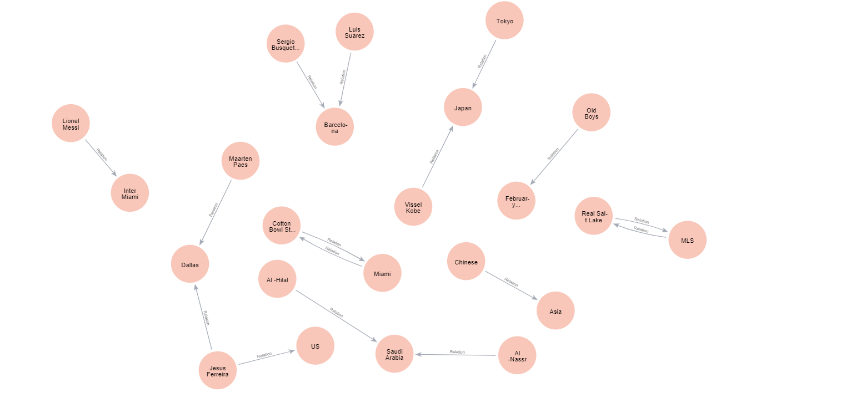
{
"LLM": "Rebel-large",
"File": "../data/Football_news.pdf",
"Processing Time": "0:00:42.570789",
"Node count": 23,
"Relation count": 16,
"Nodes": [
"Miami",
"Saudi Arabia",
"Maarten Paes",
"US",
"Lionel Messi",
"Dallas",
"February 15",
"Old Boys",
"Vissel Kobe",
"Japan",
"Al -Hilal",
"Jesus Ferreira",
"Tokyo",
"Inter Miami",
"Al -Nassr",
"Cotton Bowl Stadium",
"Barcelona",
"MLS",
"Luis Suarez",
"Real Salt Lake",
"Chinese",
"Sergio Busquets",
"Asia"
],
"Relations": [
"home venue",
"occupant",
"continent",
"point in time",
"subsidiary",
"league",
"country",
"member of sports team",
"member of sports team",
"member of sports team",
"country",
"country",
"country",
"member of sports team",
"member of sports team",
"member of sports team"
]
}

OpenAI-GPT-3.5-turbo-16k
extract structured information from natural language.
Able to have add nodes with different labels and creates a lot of relationships.
For some nodes have ambiguity

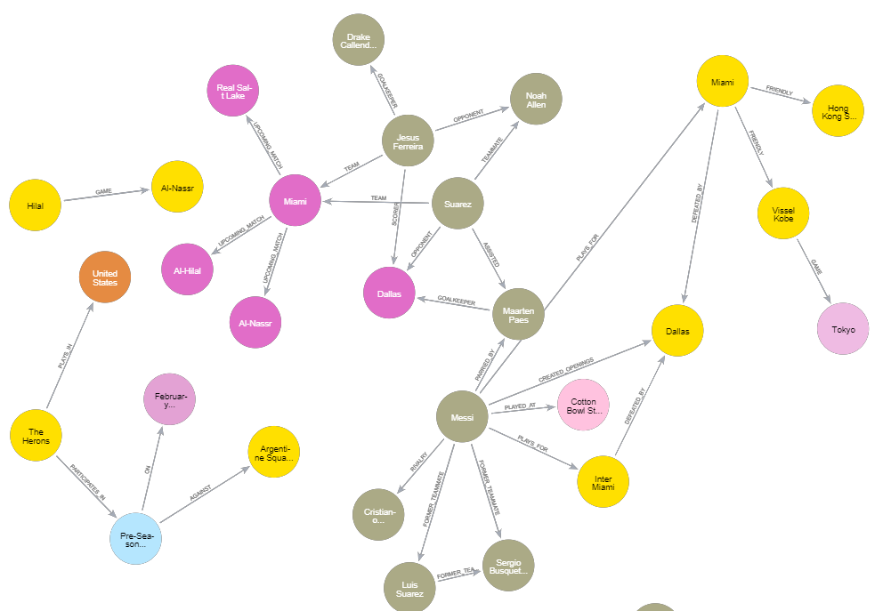

{
"LLM": "OpenAI-GPT-3.5-turbo-16k",
"File": "../data/Football_news.pdf",
"Processing Time": "0:00:43.126397",
"Node count": 25,
"Relation count": 31,
"Nodes": [
"The Herons",
"Suarez",
"Cristiano Ronaldo",
"Drake Callender",
"Maarten Paes",
"Al-Hilal",
"Tokyo",
"Dallas",
"Noah Allen",
"Vissel Kobe",
"Pre-Season Game",
"Real Salt Lake",
"Sergio Busquets",
"Luis Suarez",
"Cotton Bowl Stadium",
"Hong Kong Select Team",
"Inter Miami",
"Fc Dallas",
"Al-Nassr",
"Argentine Squad Newell'S Old Boys",
"Messi",
"Jesus Ferreira",
"United States",
"Hilal",
"Miami"
],
"Relations": [
"plays_for",
"former_teammate",
"former_teammate",
"former_teammate",
"plays_for",
"defeated_by",
"created_openings",
"parried_by",
"played_at",
"goalkeeper",
"assisted",
"team",
"teammate",
"opponent",
"scorer",
"team",
"opponent",
"goalkeeper",
"opponent",
"upcoming_match",
"upcoming_match",
"upcoming_match",
"game",
"rivalry",
"friendly",
"friendly",
"game",
"plays_in",
"participates_in",
"against",
"on"
]
}

Diffbot
Able to add few properties but with single node only.
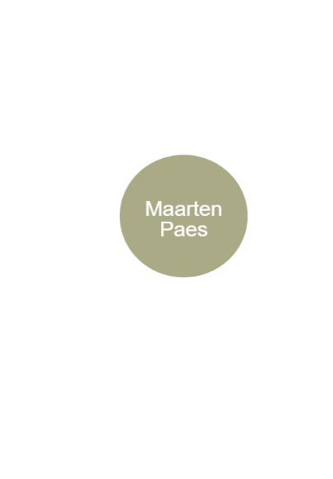
{
"LLM": "Diffbot",
"File": "Football_news.pdf",
"Processing Time": "4.5s",
"Node count": 1,
"Relation count": 0,
"Nodes": [
"Maarten Paes"
],
"Relations": []
}

Human Extraction
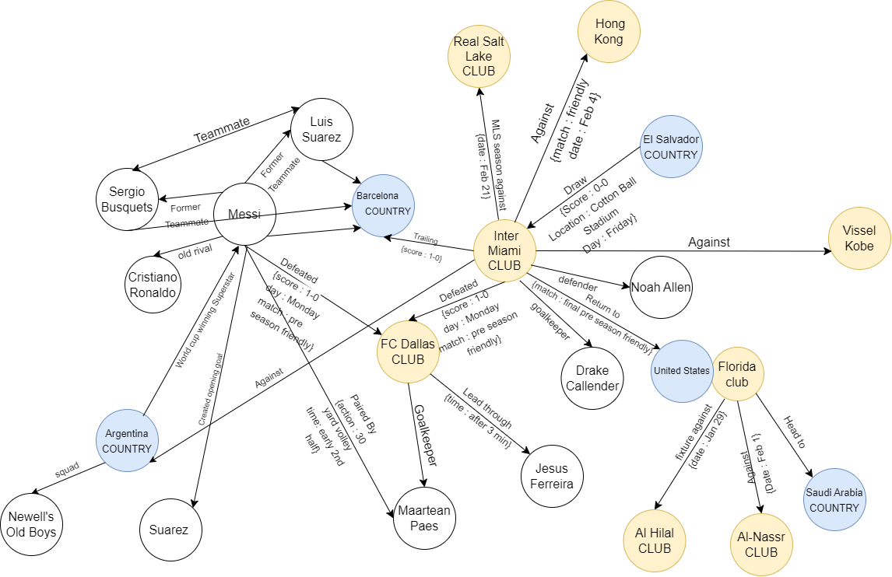

{
"LLM": "Human Extraction",
"File": "Football_news.pdf",
"Node count": 22,
"Relation count": 24,
"Nodes": [
"Sergio Busquets",
"Cristiano Ronaldo",
"Luis Suarez",
"Messi",
"Barcelona",
"Argentina",
"Suarez",
"FC Dallas",
"Maartean Paes",
"Real Salt Lake",
"Inter Miami",
"Jesus Ferreira",
"Drake Callender",
"Noah Allen",
"Hong Kong",
"El Salvador",
"United States",
"Vissel Kobe",
"Florida club",
"Al Hilal",
"Al-Nassr",
"Saudi Arabia"
]
,
"Relations": [
"Against",
"Against",
"Against",
"Against",
"teammate",
"teammate",
"Former teammate",
"Former teammate",
"old rival",
" World cup winning Superstar",
"Created opening goal",
"defeated",
"defeated",
"Paired by",
"goalkeeper",
"goalkeeper",
"trailing",
"lead through",
"defender",
"return to",
"MLS season against",
"Draw",
"fixture against",
"head to",
“squad”

]
}

